|  |
| --- |
| Holo WMH |
| The AR project that provides enhanced table-top wargaming experience |
| Jianxiong Liu & Zhuo Li |

1. **Overview**

The Holo WMH is a project that aims to build an augmented reality world of the Warmachine/Hordes game system, using the interaction interface provided by the AR device to enhance the gaming experience of the otherwise traditional table-top wargaming.

This project also serves as a platform for those involved to practice the programming of and interfacing with the new AR device. As a side project to our real life job, this project also needs to be concentrated and not overly ambitious.

As the Hololens is going to be strongly supported by Microsoft’s new Universal Windows App framework, as well as by Unity engine, the development will be in C# which is the only language that is supported across these environments. Unity engine has announced direct support of Hololens projects, and is already used by Microsoft in Build 2015 conference to demonstrate the easiness of developing Hololens apps. Therefore Unity engine will be the main host of this project.

In this early version of the Functional Description, a brief overview of the project as well as essential features that a table-top wargming game needs are listed for discussion.

1. **Features**

The Holo WMH project aims to build an interactive AR world that provides the players the enhanced experience of playing Warmachine/Hordes games without using any physical miniature or tool. This allows the player to play anywhere without carrying large army bags and scenery boxes. It also allows players to battle each other over internet, as if both are playing in front of the same physical table.

More importantly, this AR world aims to provide players enhanced ability to interact with game objects. Examples include model fighting animations, unit information display, accurate template placing and distance measuring, battlefield effect, etc.. 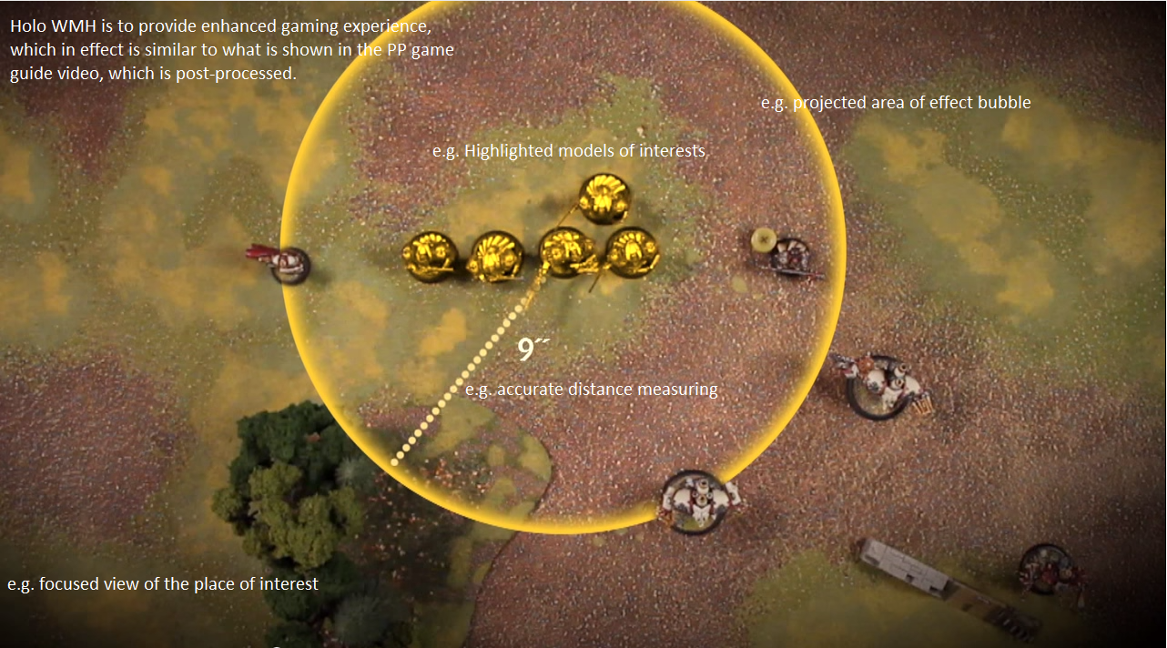

Exploiting the AR interaction is essential to this project.

1. **The core of the system**  
   In this section the bare minimum functions and features of the Holo WMH system are listed. Implementing these basic features will result in a playable Holo WMH game, albeit being only a rough implementation.
   1. The stage/world construction  
      Building the game table and projecting it as holograms onto physical world is the first step of the game. It requires the system to correctly align with real world object, building and placing down (or even hang in the air) the 3D game table. Thereafter the rest of the game will be carried out on this virtual table. This table serves as the reference plane for all other game objects.  
      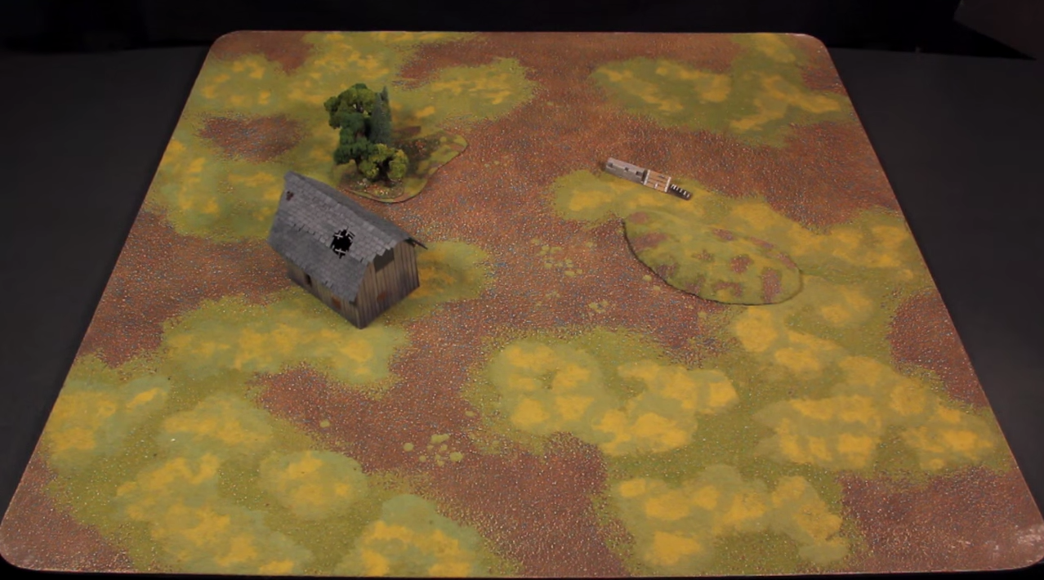
   2. Action control panel

The core of AR interaction is to be achieved via control panel. To illustrate, refer to the demo on Build 2015. This control panel gives player more options to interact with game objects, calling other advanced AR enhanced features such as resolving ranged attacks.

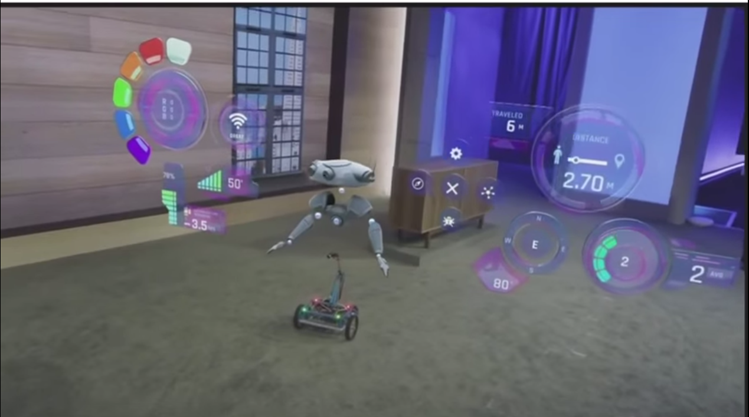

* 1. Basic function: moving models  
     The very basic action -- or the bare minimum -- of the table-top wargming is moving models/miniatures around. The game engine MUST allow players to select a object, be it model or terrain piece, and place it in any other location on the game table.

It is very IMPORTANT though, to implement this function in such a way that before determining the final location of the selected object, the object must remain unmoved. This is due to the requirement of the Warmachine/Hordes game mechanism.

Therefore, the desired behaviour should be: 1) player selects a game object; 2) the game object is highlighted and a half transparent copy of the object is attached to the player’s cursor; 3) the player moves the cursor, dragging the object copy to the desired place; 4) a distance measure is always shown between the original object and the copy on the cursor; 5) when player confirms the new location he is asked to change the facing of the model; 6) the original object is moved there and facing the desired direction.  
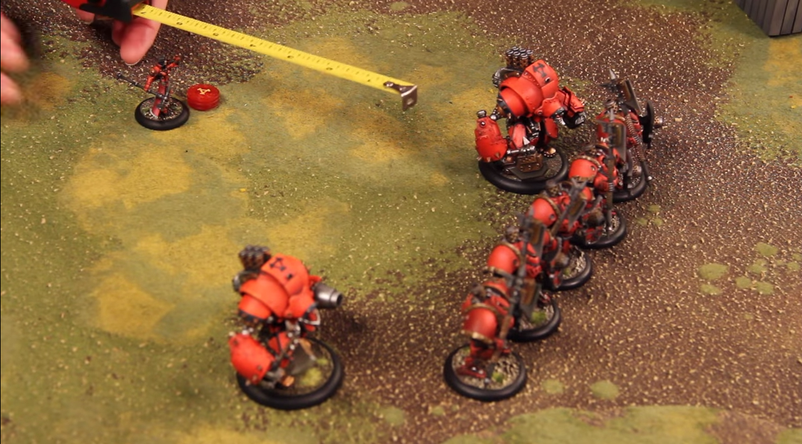

* 1. Basic function: manual distance measuring  
     While we will implement various distance measuring functionalities later on to assist player on the game, it is very important to offer players the ability to measure the distance between any two points on the game table.  
     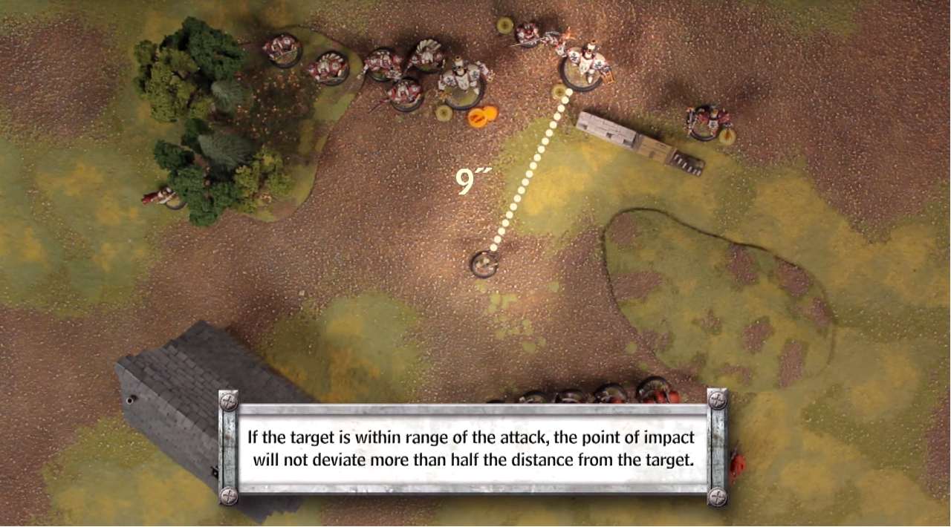
  2. Basic function: dice rolling  
     While we will implement various automated dice rolling/resolving functionalities later on, it is very important to offer players the ability to roll a specific number of d6 dice at any time they want.

With the above functionalities implemented, players are able to play Holo WMH right away.

1. **Augmented reality features**

This section lists some of the more advanced AR features that can enhance the gaming experience, and make Holo WMH truly attractive.

* 1. Automated line of sight measuring

While players can determine line of sight from model A to model B using their own eyes, it will be useful to offer this LoS testing function. It tests the LoS between the two models in question appointed by players. Or, it can highlight any other model that are visible to a selected model (or the model copy being dragged around by the cursor).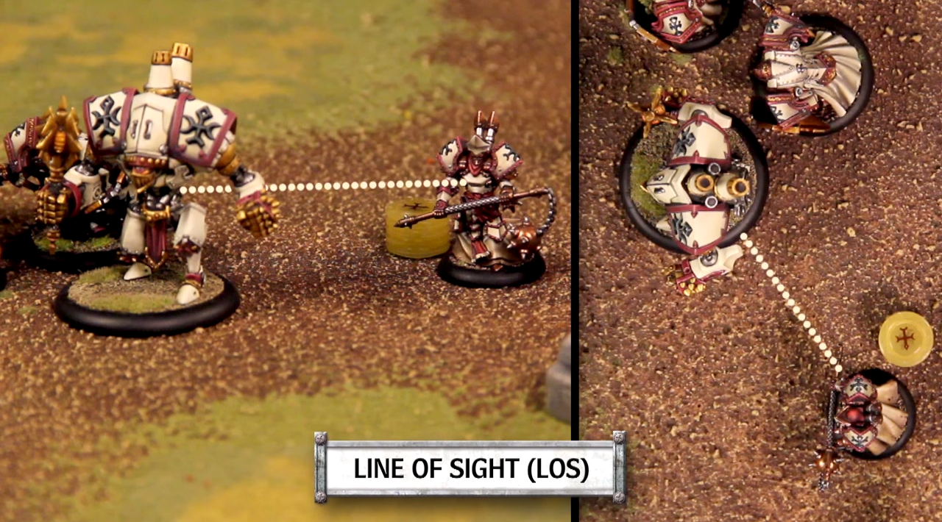

* 1. Automated action resolving: melee attack

Melee attack can be resolved automatically. Player can choose to do melee attack via the control panel, the melee range of the model is displayed, and player chooses a valid target to attack. Then everything else is automatically resolved, including dice rolling and other attack effects (e.g. pushing target model).

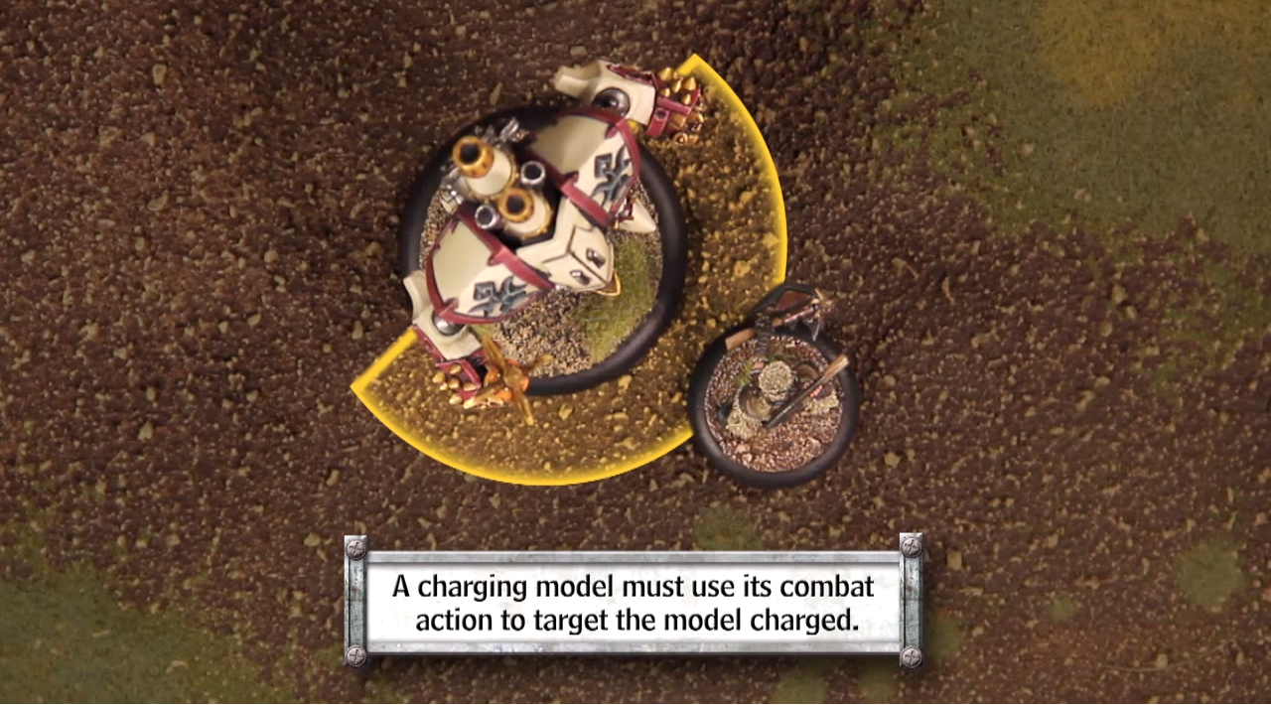  
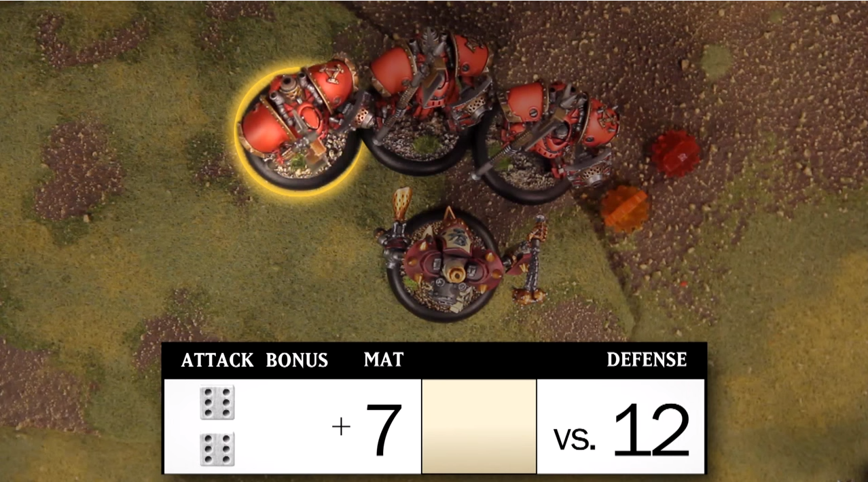

* 1. Automated action resolving: ranged attack/magic attack

Automated ranged attack can also be implemented, and is potentially more useful than automated melee attack. This is because ranged attack involves more measuring actions. After the player chooses to do a ranged attack or magic attack from the control panel, he is asked to declare a target in LoS before knowing the actual distance. Then the system will automatically resolve the distance, spray template placement, attack and damage roll, and AoE template deviation.  
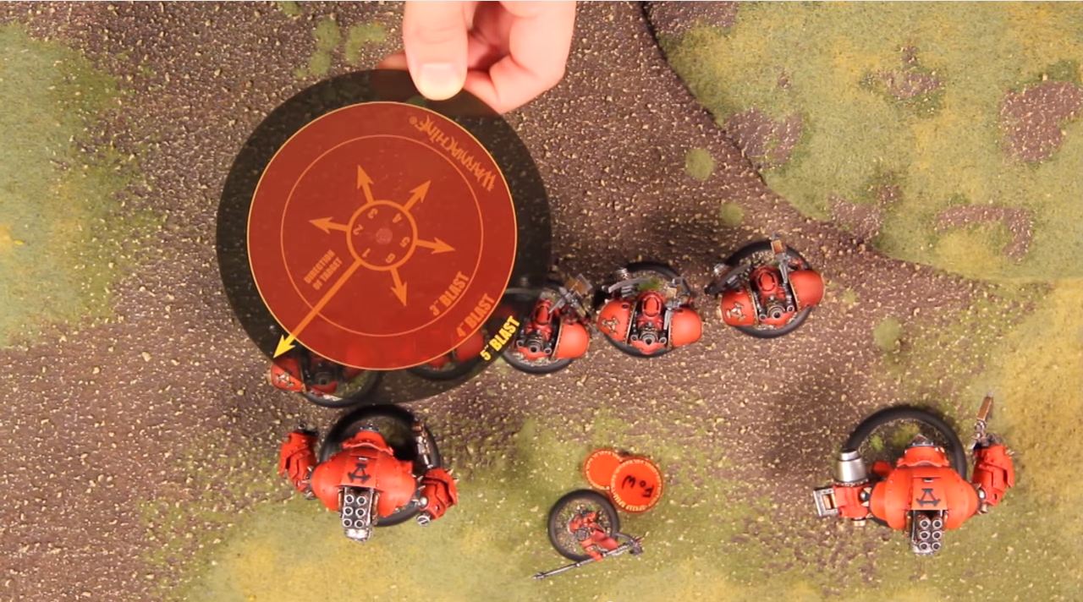  
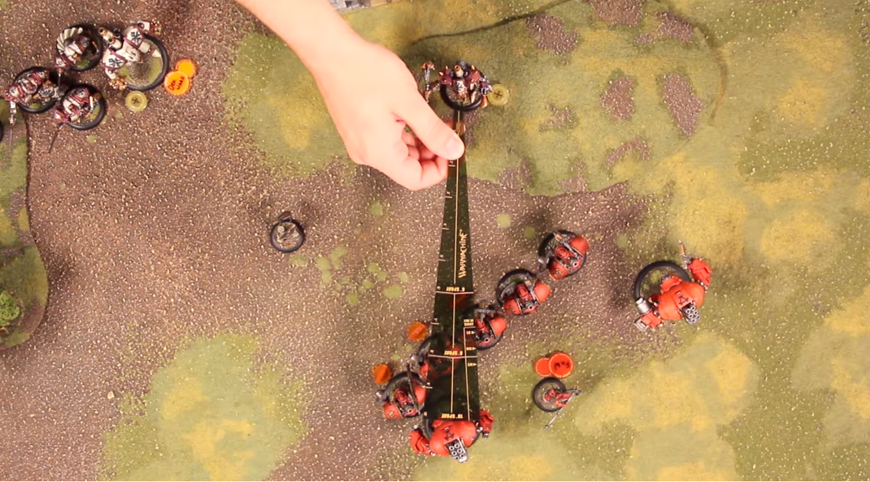

* 1. Info display of the model  
     It will be useful to display all abilities and status of a selected model, besides the model itself. This will also serve in our potential future AR project, e.g. face recognition app.

1. **Multiplayer gaming**  
   Hololens has been demonstrated in various occasions that it can easily share the same hologram world with other Hololens devices. This enables the multiplayer gaming and is absolutely essential to Holo WMH. However, details of this part of implementation has to wait till the release of the device.
2. **Art related issues**

While art is not part of the core mechanism that is essential to this project, it will become important later on when the system is established. Unity engine allows for easy substitution of 3D models of game objects, therefore as long as we keep it in mind when developing the game world it won’t be a problem in the future to swap in updated 3D models/textures/animations.

There are various ways to acquire art related assets, one of which is to build them ourselves using 3D modelling software. While this is possible, it will not be of great interest to us and will be time consuming. Out sourcing the work to others is another solution, while being potentially costly.

A last solution is to develop a 3D scanning system that makes use of the AR device, to scan in real painted miniatures and build their 3D counterparts automatically. This has been a research topic for years, but further investigation into the subject is needed to assess the practicality. (Refer to Intel RealSense 3D scanning SDK, free)